Detailed Design Specifications
FOR
Volunteer Management System
(VMS)

CLIENT | Liu Peishan
PROJECT | Volunteer Management System
TITLE | Detailed Design Specifications
VERSION | 0.1a
DATE | 02-Jan-2012
 | ORIGINATOR
 | Name / Signature | Team 8S
 | APPROVAL
 | Name / Signature | Phung Kim Cuong, Dio
Institute of Systems Science |  | Document Reference
25 Heng Mui Keng Terrence  Singapore 119615 |  | VMS/T-1.5.4/1

 | Acceptance
 | Customer Signature |  | Customer Signature
 | Name & Designation |  | Name & Designation
 | Date & Company Stamp |  | Date & Company Stamp

Revision History

Date | Version | Description | Author
02-Jan-2012 | 0.1a | Creation | Team 8S

Table of Contents

1. UCRR (Design) – Register Volunteer Account 3
1.1 Brief Description 3
1.2 Flow of Events 3
1.2.1 Standard Flow 3
1.3 Interaction Diagrams 3
1.3.1 Sequence Diagram: Register Volunteer Account 3
1.4 Class Diagram 5
1.5 Derived Requirement 5
2. UCRR (Design) – Update Profile 6
2.1 Brief Description 6
2.2 Flow of Events 6
2.2.1 Standard Flow 6
2.3 Interaction Diagrams 6
2.3.1 Sequence Diagram: Update Profile 6
2.4 Class Diagram 9
2.5 Derived Requirement 9
ANNEX D Amendment History 10

Detailed Design Specifications

UCRR (Design) – Register Volunteer Account

Brief Description
The use case describes the new volunteer account registration of VMS system.

Flow of Events
The standard flow of events and alternative flow of events for this use case and any exceptions are described in the following subsections. The events are described in terms of Actors, Design Objects and object operations.

Standard Flow
Refer to the sequence diagram.

Interaction Diagrams

Sequence Diagram: Register Volunteer Account
Refer to next page.

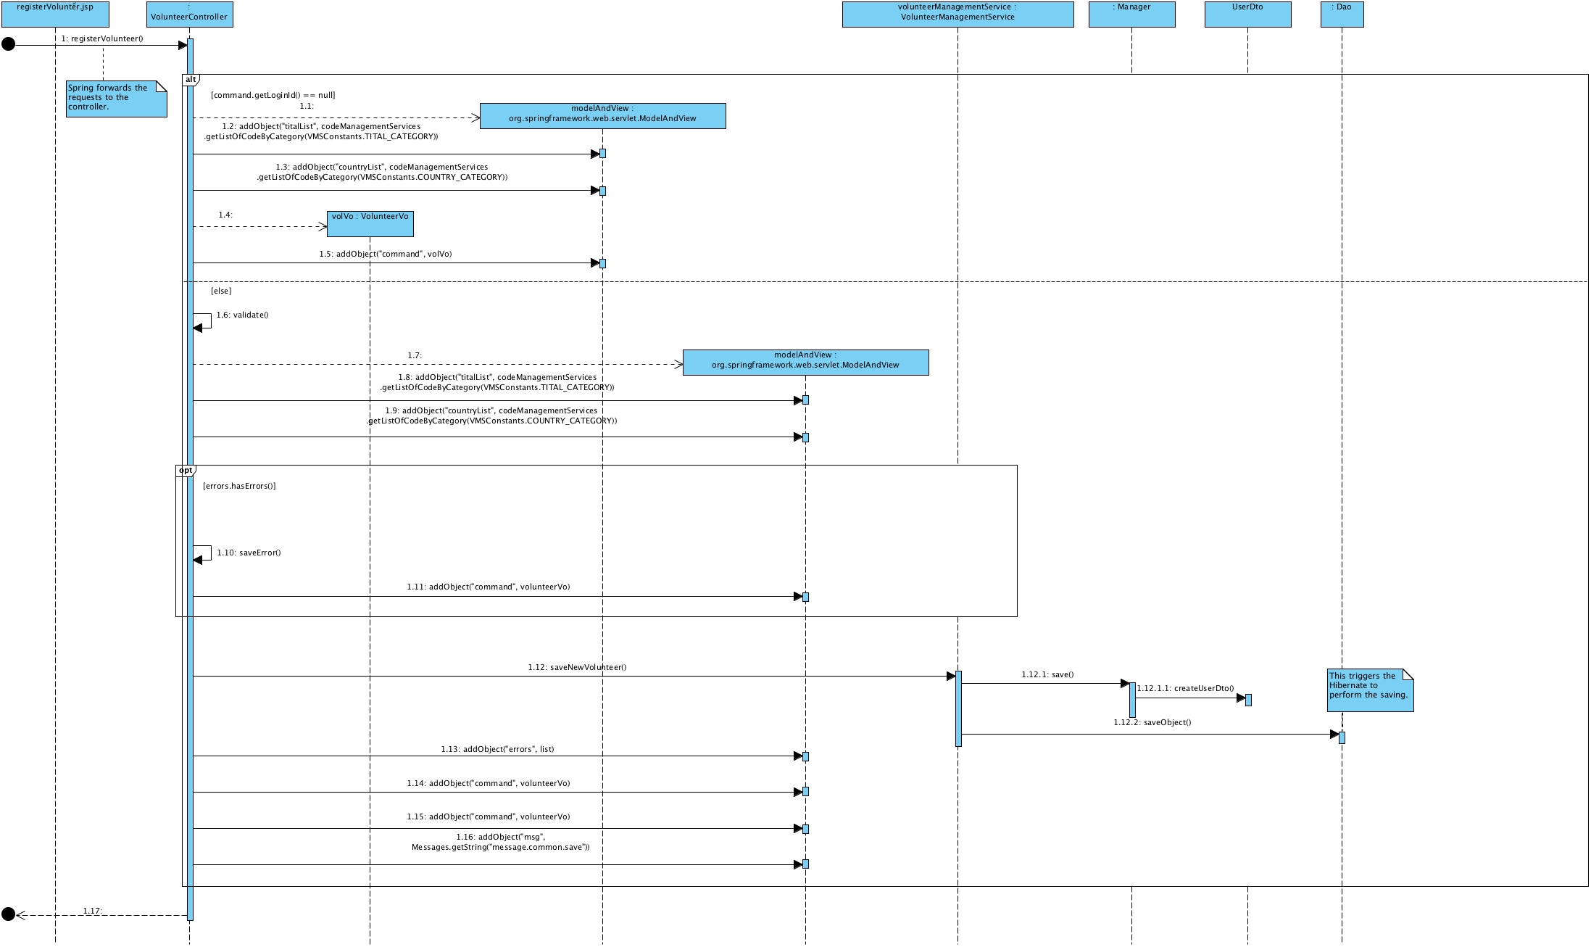
Figure 1 – Sequence Diagram: Register Volunteer Account

Class Diagram
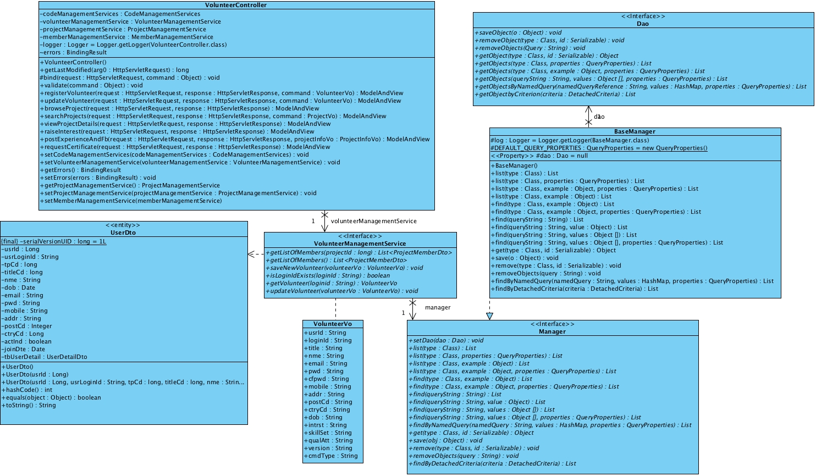
Figure 2 – Class Diagram

Derived Requirement
The User office PC (client system), keyboard and mouse will be used to process the project details and view all the system responses.

UCRR (Design) – Update Profile

Brief Description
The use case enables registered User to update his/her profile.

Flow of Events
The standard flow of events and alternative flow of events for this use case and any exceptions are described in the following subsections. The events are described in terms of Actors, Design Objects and object operations.

Standard Flow
Refer to the sequence diagram.

Interaction Diagrams

Sequence Diagram: Update Profile
Refer to next page.

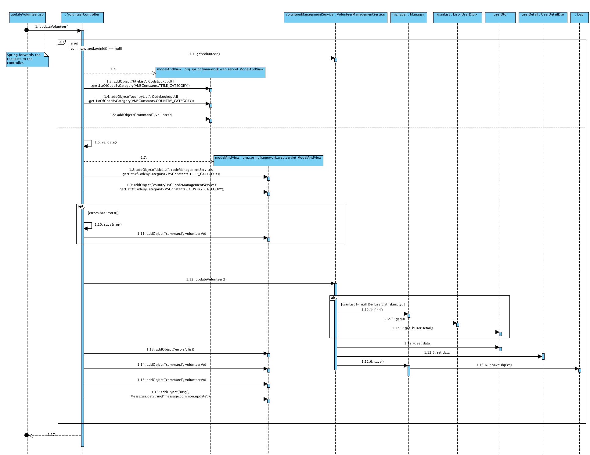
Figure 3 – Sequence Diagram: Update Profile

Class Diagram
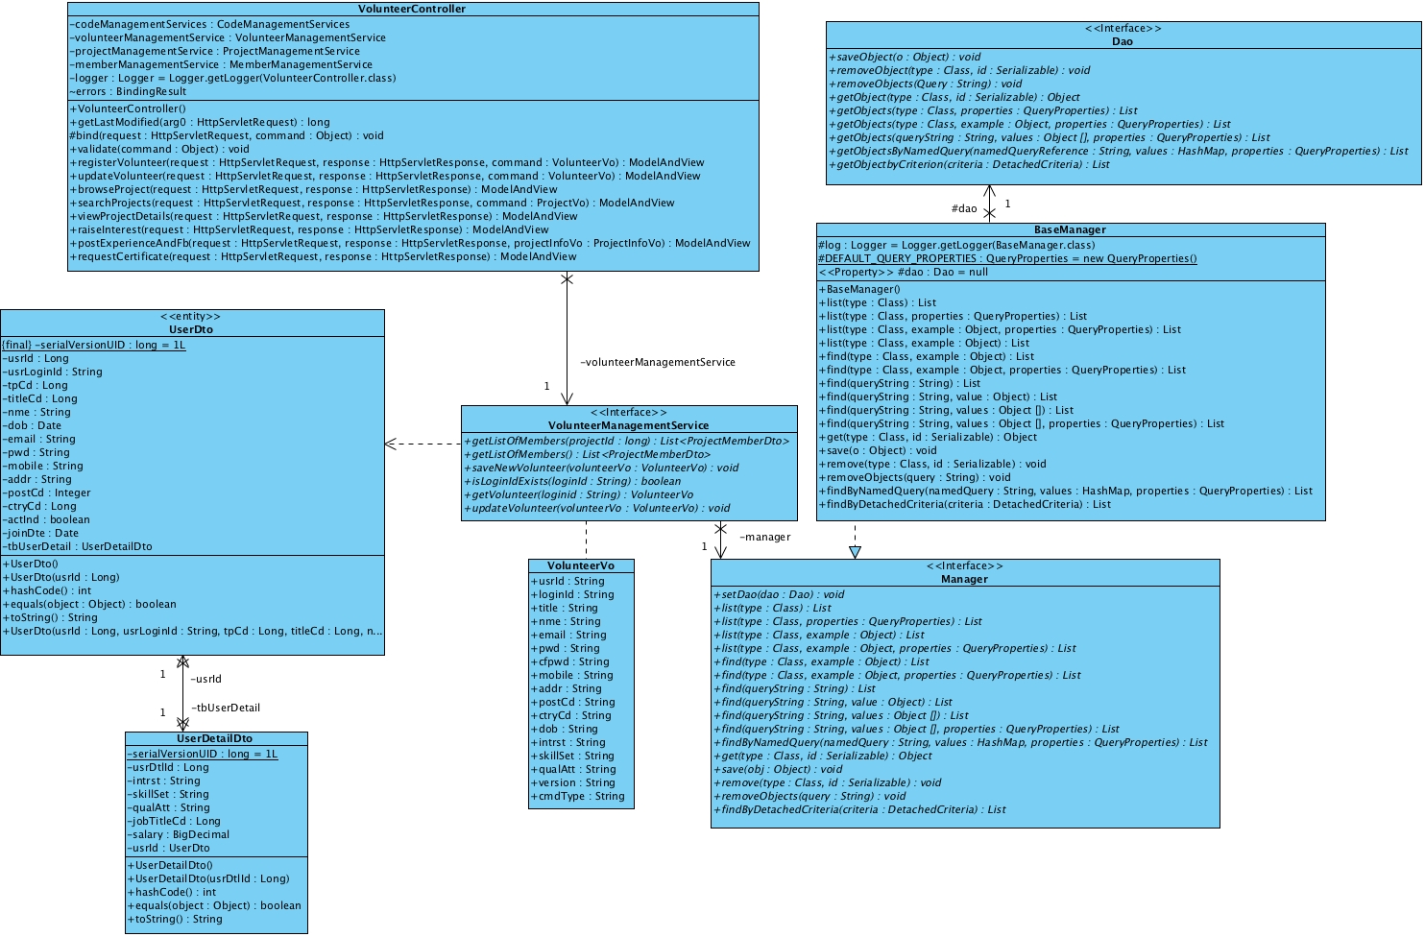
Figure 4 – Class Diagram

Derived Requirement
The User office PC (client system), keyboard and mouse will be used to process the project details and view all the system responses.

ANNEX D Amendment History

This is a record of all amendments made to the Document.
Version | Chapter / Section | Page No | Notes of Amendments or Changes

